Day 25: 18-11-2025:

DevOps team
Agile, Git, Maven, Gradle, Docker etc.

Docker is an advanced OS virtualization open source software platform that makes it easier to create, deploy and run the application in docker container.
Using Docker container we can create containerization application.

Virtualization Vs Containerization
Container : it is a run time environment. Which is responsible to run docker images.
One machine one OS
In one machine we can multi OS.
But we can only one OS at time.

VM ware software : with help of VMWare we can run OS images. Abstract version of an OS is known as virtualization.
Limitation of an virtualization base machine need to share the resources. Like RAM, external Memory etc.
Containerization is a type of adv Virtualization we can creating abstract version of an application.

Docker images Docker image is read only template file which is responsible to run the application with help of docker container.
Docker file : Docker file contains set of instruction with their dependencies which help to run the application.
Using the Docker file we build the image.
Help of images we can run the application in Docker environment.

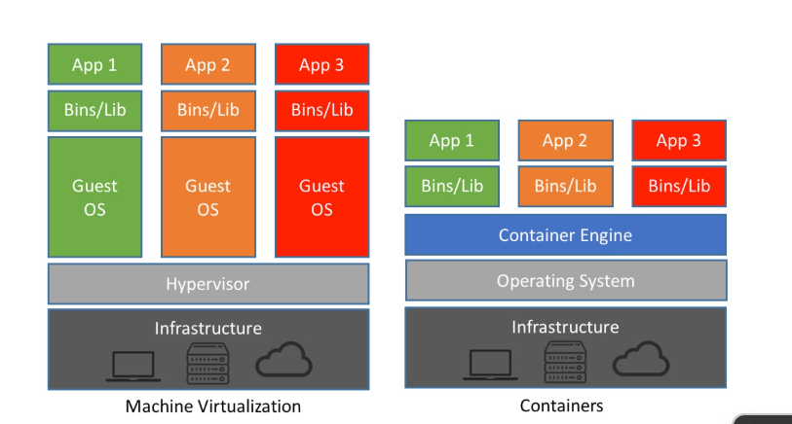

Install docker, launch docker desktop. Create docker hub account.

Docker hub is like a github. Which provides images it may pre defined as well as user defined.
We can push and pull images from docker hub.

Open the command prompt

docker --verion
docker info

docker images it show all images present in current machine.

docker pull imageName this command pull the image from docker hub

hello-world

running the application using image
docker run imageName/ImageId : run the image. Once you run the image. Image run the application with help of docker container.

Creating image to display simple message
Create a file with name as Dockerfile
Write below code

FROM busybox:latest
CMD ["echo","This image created by Akash!"]

To build the image we need to run below command

docker build -t my-busybox . -f Dockerfile

docker images

docker run my-busybox

Creating image to run Java program

Demo.java

public class Demo {
public static void main(String args[]){
System.out.println("Welcome to Java...");
}
}

Creating docker image to run the Java Program

Dockerfile

FROM eclipse-temurin:17-jdk
COPY . .
RUN javac Demo.java
CMD ["java", "Demo"]

Build the image

docker build -t my-java . -f Dockerfile

docker run my-java

creating the image to run spring boot application

